Personal Portfolio Website
Minor Project-II
(ENSI252)
Submitted in partial fulfilment of the requirement of the degree of
BACHELOR OF TECHNOLOGY
in
CSE with Specialization (AI-ML)
to
K.R Mangalam University
by
Shubhi Tyagi (2301730132)
Aryan Sharma (2301730119)

Under the supervision of
Dr.Vandna Batra

Designation


Department of Computer Science and Engineering
School of Engineering and Technology
K.R Mangalam University, Gurugram- 122001, India
April 2025

CERTIFICATE

This is to certify that the Project Synopsis entitled, “PERSONAL PORTFOLIO WEBSITE” submitted by “ ,Shubhi Tyagi(2301730132) , Aryan Sharma (2301730119), to K.R Mangalam University, Gurugram, India, is a record of bonafide project work carried out by them under my supervision and guidance and is worthy of consideration for the partial fulfilment of the degree of Bachelor of Technology in Computer Science and Engineering of the University.

Type of Project:
Industry Problem

Signature of Internal supervisor
Mr. Sohan Padhikar
Faculty

Signature of Project Coordinator
Dr. Vandna Batra

Date: 29th April 2025

INDEX

S.No. | Title | Page No.
 | Abstract | 4
 | Introduction (description of broad topic) | 5
 | Motivation | 6
 | Literature Review/Comparative work evaluation | 7
 | Gap Analysis | 8
 | Problem Statement | 9
 | Objectives | 10
 | Tools/platform Used | 11
 | Methodology | 14
 | Results And Discussion | 18
 | Conclusion & Future Work | 20
 | References | 21

ABSTRACT
The increasing need for enhanced home security has led to the evolution of traditional surveillance systems into intelligent, automated solutions. Despite the widespread deployment of conventional CCTV cameras, they often fall short in providing real-time insights and proactive monitoring capabilities. To address these limitations, we propose the development of a SMART CCTV system powered by Artificial Intelligence and Machine Learning. This solution integrates features such as facial recognition, in-out movement detection, and motion-based noise detection—delivered through a user-friendly Python GUI. The system is designed to operate locally using OpenCV and other Python libraries, ensuring accessibility and cost-efficiency. By automating the detection process and enabling intelligent alerts, this project aims to improve situational awareness, reduce manual surveillance burden, and provide peace of mind for household environments. This approach not only strengthens residential security but also opens avenues for further scalability into broader public safety applications.
KEYWORDS: Smart Surveillance, Facial Recognition, Motion Detection, Artificial Intelligence, Python GUI

Chapter 1
Introduction

1. Background of the project
In today’s competitive academic and professional landscape, a well-organized and visually engaging digital portfolio has become essential for individuals in the field of computer science and software development. Traditional resumes and LinkedIn profiles, while useful, often fall short in providing a complete picture of one’s technical expertise, creative problem-solving ability, and project experience. To address this gap, I developed a personal portfolio website that serves as a centralized platform to showcase my skills, academic projects, certifications, and technical journey.
The primary aim of this project is to build a responsive, interactive, and professional web presence that not only highlights my work but also reflects my personal brand. The website provides a structured layout where users can explore my resume, project documentation, GitHub repositories, and contact information—all in one place.
Developed using modern front-end technologies such as HTML, CSS, and JavaScript (and optionally React or Bootstrap), the portfolio is optimized for both desktop and mobile platforms. Key features include a downloadable CV, categorized project sections with detailed write-ups, live demos or GitHub links, and a clean, user-friendly interface.
This project also provided an opportunity to apply real-world development practices such as responsive design, modular code structure, version control using Git, and performance optimization. It is not only a representation of my work, but also a project in itself—demonstrating my web development skills, attention to detail, and ability to present technical content effectively.
The personal portfolio website serves as a dynamic, evolving space that grows with my academic and professional journey, and is intended to leave a lasting impression on educators, recruiters, and collaborators alike.

2. MOTIVATION
As a student in the field of computer science, I recognized the importance of having a strong digital presence to effectively showcase my skills, experiences, and project work. Traditional resumes and profiles often limit how much detail and personality can be conveyed. This inspired me to develop a personal portfolio website—a platform that not only acts as my digital resume but also reflects my creativity, technical abilities, and professional journey.
The motivation behind this project stems from the need to stand out in a competitive field and present my work in a format that is both interactive and accessible. It allows me to share my projects with source code, documentation, and visuals, all in one place. Additionally, the process of building the website itself helped me apply and enhance my front-end development skills, making this both a personal branding tool and a technical learning experience.

Chapter 2

LITERATURE REVIEW

- Review of existing literature
With the increasing importance of digital identity in today’s professional landscape, personal portfolio websites have become a valuable tool for individuals—particularly students and developers—to showcase their work and skill sets beyond the limitations of a traditional resume. These platforms are increasingly recognized as a strategic medium for career development, providing interactive, real-time access to an individual’s academic background, projects, certifications, and technical capabilities.
Existing literature highlights the benefits of personal branding through websites, emphasizing how they enhance visibility, credibility, and personalization. Studies show that candidates with professional portfolios often receive higher engagement from recruiters and collaborators, as such platforms provide detailed and navigable insights into one's competencies and accomplishments.
Key components observed in successful portfolio websites include:
User-friendly interfaces to ensure ease of navigation and clarity of content
Responsive design for cross-device accessibility and a consistent user experience
Project documentation integration for showcasing real-world work and technical applications
Downloadable resumes and contact forms to enable seamless professional interaction
Research in digital portfolio development also underscores the importance of UI/UX principles, accessibility, and search engine optimization (SEO) to increase reach and usability. Web technologies such as HTML5, CSS3, JavaScript, and frameworks like React are commonly recommended for building lightweight, responsive, and maintainable portfolio platforms.
Incorporating modern web development practices not only supports aesthetic and functional goals but also demonstrates hands-on experience. Case studies involving students and early-career professionals suggest that a well-crafted portfolio website significantly boosts networking potential and career opportunities, especially when combined with version control (e.g., GitHub integration) and project walkthroughs.
Therefore, the personal portfolio website stands as both a learning tool and a professional asset—bridging the gap between education and employability in the digital era.

2. GAP ANALYSIS

Current Challenges:

•Limited Digital Presence – Lack of a centralized platform to present skills, projects, and achievements in a professional format.

• Scattered Project Representation – Projects and code are often spread across different platforms (e.g., GitHub, LinkedIn), making it difficult for recruiters to view everything at once.

• Non-interactive Resumes – Traditional resumes cannot showcase live project demos, source code, or detailed write-ups effectively.

• Lack of Personal Branding – Absence of a personalized online space limits visibility and individuality in a competitive tech landscape.

• Minimal Engagement Tools – No structured way to allow employers or collaborators to contact or follow up professionally.

Proposed Solution:

< Develop a personal portfolio website to serve as a centralized, professional online identity.

< Integrate academic and project highlights with detailed documentation, GitHub links, and live previews.

<Provide downloadable resume and contact form for easy outreach by employers or mentors.
< Implement responsive and user-friendly design for accessibility across all devices.
Continuously update the portfolio to reflect ongoing growth, new skills, and recent projects.

Develop a personal portfolio website to serve as a centralized, professional online identity.
Integrate academic and project highlights with detailed documentation, GitHub links, and live previews.
Provide downloadable resume and contact form for easy outreach by employers or mentors.

PROBLEM STATEMENT
In today's digital world, having an online presence is essential for showcasing professional achievements, skills, and projects. However, many individuals struggle to create an organized, visually appealing platform that effectively displays their work and achievements. Existing portfolio websites often lack personalization, interactivity, or do not adequately reflect the individual’s growth, skills, and accomplishments.
The problem I aim to solve is creating a comprehensive, user-friendly personal portfolio website that provides an organized, intuitive interface for potential employers, collaborators, or clients to explore my work. This website will highlight my projects, coding skills, and professional journey, ensuring that each element is easily navigable and visually aligned with my personal brand.

OBJECTIVES
The primary objective of my personal portfolio website is to:
- Showcase Professional Projects: Provide an organized and interactive platform to present my key projects, including detailed descriptions, technologies used, and outcomes achieved.
2-Highlight Skills and Expertise: Offer an overview of my technical and soft skills, demonstrating my proficiency in coding, problem-solving, and project management.
3-Provide a Clear Career Journey: Clearly outline my professional background, including education, certifications, and work experience, to present a cohesive story of my career development.
4-Enhance Visibility: Make it easy for potential employers, collaborators, and clients to discover and connect with me, facilitating opportunities for career growth and collaboration.
5-Reflect Personal Branding: Ensure the design and content of the website align with my personal style and values, making the portfolio a true reflection of my professional identity.

CHAPTER 3: METHODOLOGY

o develop the personal portfolio website, I began by defining key features such as project showcases, skill displays, and contact information. I used HTML, CSS, and JavaScript (React.js) for the frontend to create an interactive and responsive design. For the backend, I utilized Node.js with Express.js to handle server-side functionalities. The website was deployed on Netlify (or GitHub Pages) for easy access, with Google Analytics integrated for tracking performance.

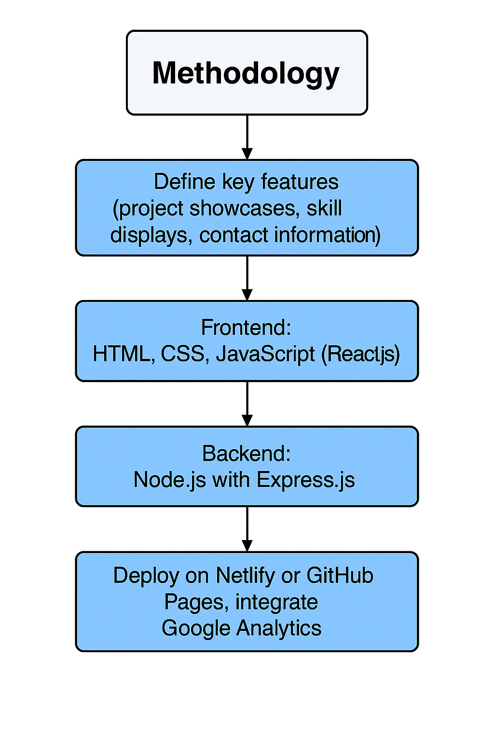

This flowchart illustrates the typical user experience and navigation flow within a personal portfolio website. It outlines how visitors interact with the site to learn about the individual, their skills, and their work. The process focuses on showcasing information and facilitating contact rather than processing transactions.
- Steps in the Process (User Interface) :

1) User Access Website

The customer initiates the process by visiting the personal portfolio website.

2) Product Selection

The customer browses and selects desired products.

3) Order Placement

After selecting the products, the customer places the order.

4) Payment Processing

Once the order is placed, the system moves to payment handling. Here, two options are available:
- Payment at Counter
- UPI (Digital Payment Method

- Store Interface:
- 1-The portfolio uses a card-based layout in the project section, resembling a store interface, where each project is displayed with an image, title, description, and link (like a product listing).
- Built using React.js and styled with Tailwind CSS (or Bootstrap), the interface ensures a responsive and smooth user experience across all devices.
- The interface design focuses on clarity, accessibility, and ease of navigation, allowing users to explore skills, projects, and personal information intuitively.

Details of tools, software, and equipment utilized.
For this project, we have used various modern technologies which are evaluated below, along with the purpose of their use.
For front-end development, HTML, CSS, and JavaScript were utilized to create a responsive and visually attractive interface. To enhance interactivity and performance, the React.js framework was used.
For the backend, Node.js and SQL were used to handle server-side logic efficiently. Express.js was implemented to create RESTful APIs and manage routing.
MySQL was used for structured data storage to manage user and contact form data effectively.
If needed, payment APIs like Razorpay and PayPal can be integrated for secure transactions.

Reasons for Selecting this language:
  - Short and Concise Language.
  - Easy to Learn and use.
  - Good Technical support over Internet
  - Many Packages for different tasks.
  - Run on Any Platform.
  - Modern and OOP language

Chapter 4

Implementation
- Project Overview

The project overview section of a personal portfolio website serves as a concise introduction to a specific piece of work, providing context, highlighting key objectives, outlining the process or methodologies employed, and summarizing the final outcome or results achieved. It aims to quickly engage the viewer and provide essential information that encourages them to explore the project in more detail.
- Key Features Implemented
For a project overview on a personal portfolio website, key features implemented might include:
- Clear articulation of the project goal: Briefly stating what the project aimed to achieve.
- Highlighting the user problem or opportunity: Explaining the context and need for the project.
- Describing the core solution or approach: Summarizing the main strategy or design direction taken.
- Mentioning key technologies or tools used: Listing relevant software, frameworks, or methodologies.
- Showcasing the final outcome or key deliverables: Presenting the tangible results of the work.
- Quantifiable achievements or impact (if applicable): Briefly mentioning any measurable success or positive effects.
- Visual elements: Incorporating images, videos, or interactive elements to illustrate the project.
- Clear call to action: Encouraging viewers to explore the project in more detail or view related work.

3. File & Component Structure

Located in src/components/:
Component File | Purpose
Home.js | Main screen with category sidebar, search, product list, and filtering.
ProductList.js | Renders products based on category/search filter.
Cart.js | Displays items in cart and total price.
CartScreen.js | Main cart interface with checkout button.
OrderSummary.js | Shows item summary before confirming order.
CheckoutPage.js | Final page before payment.
PaymentMethod.js | Lets user select payment type and handles logic for scanner visibility.
Home.css | Styles everything: sidebar, product cards, buttons, etc.

These are the codes

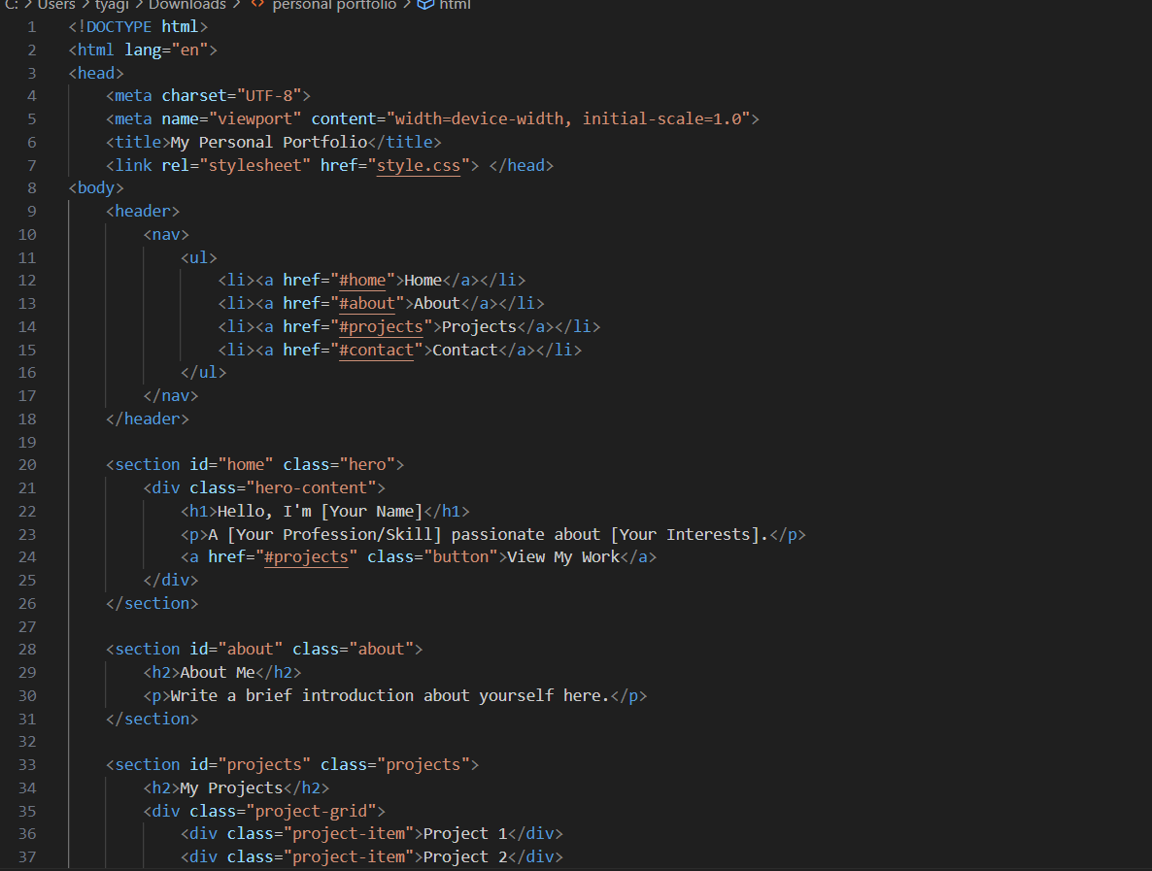

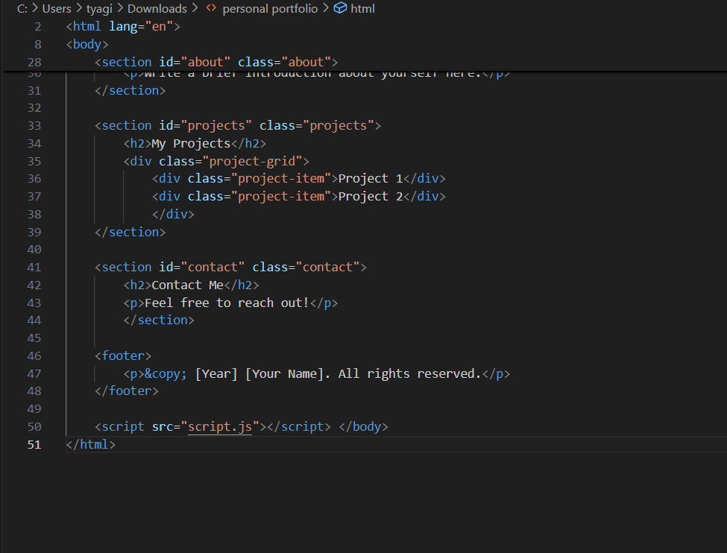

Chapter 5

RESULTS AND DISCUSSIONS
- Home page

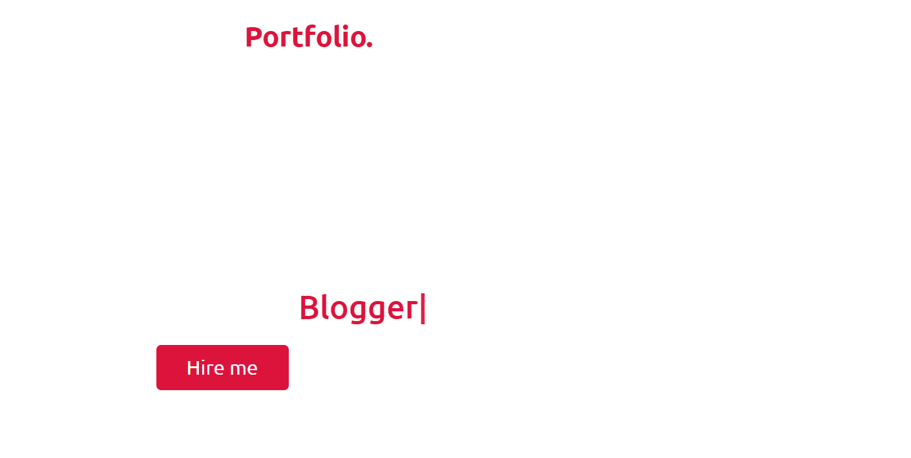

User Image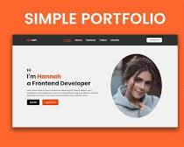

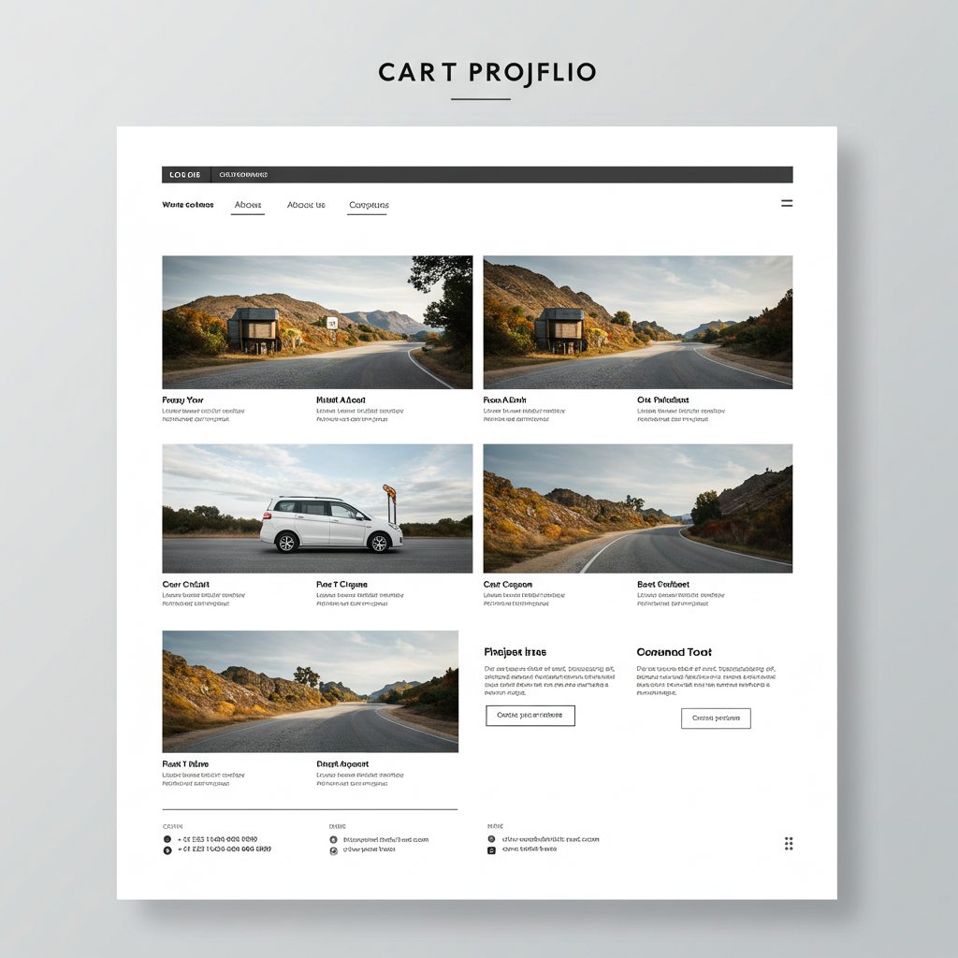

Chapter 6

CONCLUSION
The personal portfolio website was successfully designed and developed to serve as a professional representation of my skills, projects, and experience. By utilizing modern web technologies such as HTML, CSS, JavaScript, React.js, Node.js, and MySQL, the website provides a clean, responsive, and interactive user experience. This project not only improved my technical knowledge in full-stack development but also enhanced my understanding of design principles, deployment processes, and user-centric development. The portfolio will continue to evolve with updates reflecting future growth, achievements, and project additions, making it a dynamic tool for showcasing my professional journey.

REFERENCES
• React Documentation – https://reactjs.org/
• Node.js Documentation – https://nodejs.org/
• Express.js Guide – https://expressjs.com/
• MySQL Reference Manual – https://dev.mysql.com/doc/
• W3Schools HTML/CSS Tutorials – https://www.w3schools.com/
• MDN Web Docs (JavaScript, HTML, CSS) – https://developer.mozilla.org/
• GitHub Pages Deployment Guide – https://pages.github.com/
• Netlify Documentation – https://docs.netlify.com/
• Razorpay API Documentation – https://razorpay.com/docs/
•νPayPal Developer Docs – https://developer.paypal.com/

